Calculator Free

Question 1 (6 marks)

(a) If $a=10$, $t=2$ and $u=5.5$, determine the value of $s$, where $s=ut+\frac{1}{2}at^{2}$. (2 marks)

(b) If $m=\frac{a+b+c}{3}$, determine the value of $a$ when $b=10$, $c=13$ and $m=9$. (2 marks)

(c) If $d=\sqrt{b^{2}-4ac}$, determine the value of $a$ when $b=3$, $c=-1$ and $d=5$. (2 marks)

Calculator Free

Question 2 (7 marks)

A group of 28 people gave a movie they had just watched together a rating of between one and five stars. Their star ratings are listed below:

|  |  |  |  |  |  |  |  |  |  |  |  |  |  |
| --- | --- | --- | --- | --- | --- | --- | --- | --- | --- | --- | --- | --- | --- |
| 2 | 4 | 4 | 2 | 2 | 1 | 4 | 4 | 4 | 2 | 4 | 3 | 3 | 1 |
| 5 | 2 | 4 | 5 | 2 | 4 | 4 | 2 | 2 | 3 | 2 | 5 | 4 | 3 |

(a) Explain why this type of data is considered categorical and choose **one** more word to further describe the data from the following list: nominal, ordinal, discrete, continuous.

(2 marks)

(b) Complete the frequency table below for the ratings. (2 marks)

|  |  |  |
| --- | --- | --- |
| Rating | Tally | Frequency |
| 1 |  |  |
| 2 |  |  |
| 3 |  |  |
| 4 |  |  |
| 5 |  |  |

(c) Display the ratings as bar graph using the grid below. (3 marks)

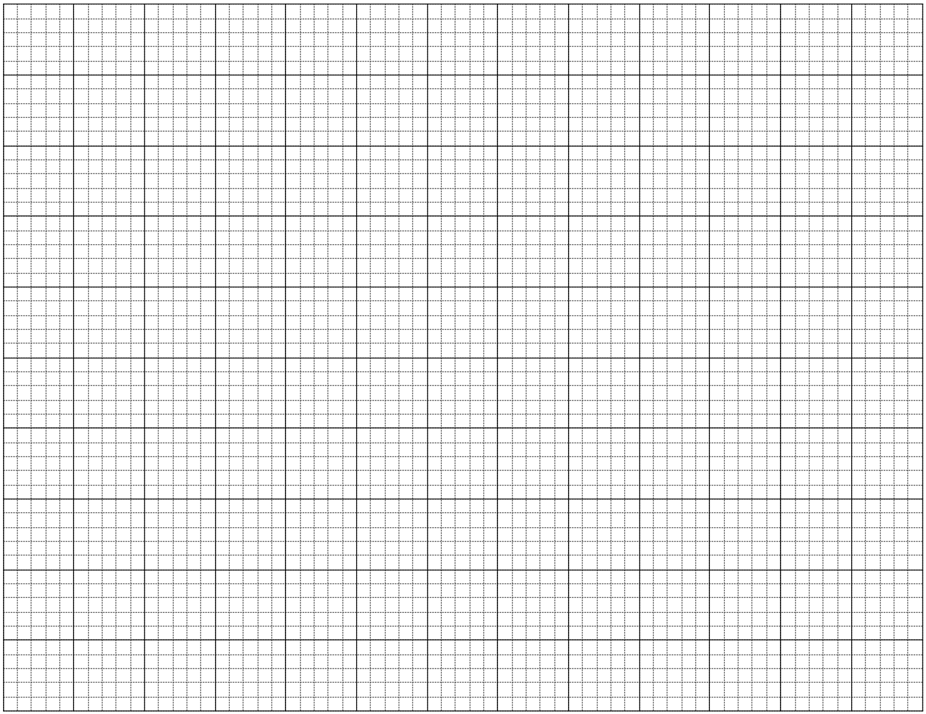

Calculator Assumed

Question 8 (6 marks)

A worker in a chemical factory earns $42.70 per hour on a weekday, time and a half at weekends, and a fixed allowance of $39.15 per day.

(a) Calculate the workers' weekly pay when she works from 9 am until 1 pm and then 1.30 pm until 4.30 pm from Wednesday to Sunday inclusive. (4 marks)

(b) Calculate the workers' total holiday pay when she takes four weeks leave, if the company pays her for 35 hours per week at her base rate, does not pay the fixed allowance but does add leave loading of 17.5%. (2 marks)

Calculator Assumed

Question 10 (6 marks)

A semi-circular grassed area has a radius of 45 m.

(a) A fence is to be installed around the edge of the area at a cost of $85 per metre. Calculate the cost of fencing to the nearest hundred dollars. (3 marks)

(b) A decorative building is to be built in the middle of the grassed area with a **hemispherical** glass roof. The cost of the building is $17 800 plus $235 per square metre for the glass used in the hemispherical roof. If the radius of the hemisphere is 4.5 m, calculate the total cost of the building to the nearest hundred dollars. (3 marks)